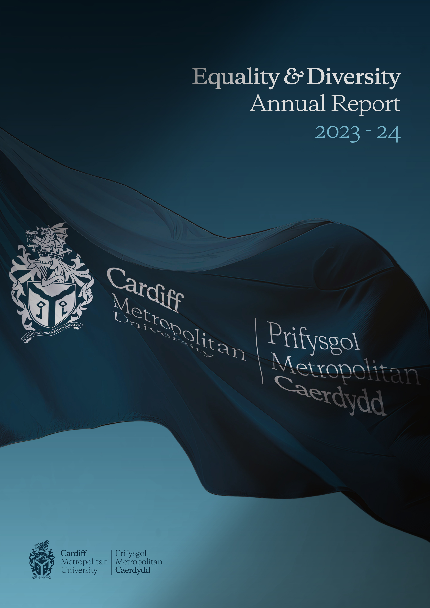

Introduction and background

Under the Specific Duties for Wales of the Equality Act 2010 the University is required to produce a Strategic Equality Plan outlining equality objectives and to publish an annual monitoring report by the 31st March each year.

The report must cover the period 1st April to 31st March of the previous year.

The current document provides progress against the following:

- Steps taken to identify and collect relevant information

- How the University has used this information

- The reasons for not collecting any relevant information

- A statement about the effectiveness of arrangements for identifying and collecting relevant information and the steps taken to fulfil each of its objectives

Identifying, Collecting & Using Relevant Information

The Steps Taken to Identify and Collect Relevant Information

Monitoring

Staff and student monitoring data are collected and analysed on an annual basis as part of the production of the University’s Equality and Diversity Annual Report. This information is collected from the University’s People Services and Student systems and analysed through our Business Intelligence Dashboards.

Equality, Diversity and Inclusion staff monitoring information is collected through the University’s online recruitment system which contains a separate EDI monitoring section. Upon application, applicants are asked for relevant monitoring information to ensure that the University meets our statutory responsibilities (the General Duties under the Equality Act 2010 and the Public Sector Equality Duty in Wales), to measure the effectiveness of our policy, ensure that all applicants continue to be treated equitably, and equally with regard to the statutory protected characteristics, and monitor the success rate of applicants with protected characteristics. It is made clear to applicants that if they do not wish to provide all or some of this information they do not need to. It is clearly stated to applicants that the collection of this information will not affect the selection process. If an applicant is successful the individual’s monitoring information is transferred into their personal HR record, within the People Services HR system.

In order to ensure that the information that the University is collecting is accurate, staff are encouraged to review and update their personal details, within the University iTrent HR System. Staff members can update a variety of contact information along with sensitive information including: religion, ethnicity, nationality and sexual orientation. This system can be accessed at any point throughout the year by staff via the ‘self-service’ option on the University’s internal staff portal. Information relating to marital status and self-certified disability can be updated through contact with People Services.

The current People Services HR system enables the production of regular reports on staff and applicant information by protected characteristics. The University has continued to streamline this process, utilising Business Intelligence data dashboards. The dashboards provide valuable insight and help inform future EDI initiatives, while also identifying any potential improvements to our data capture and reporting processes.

The University has benchmarked the way that it assesses the Welsh language skills of its staff against other mechanisms used by the public sector in Wales. This framework has 5 levels of ability based on ‘can do’ statements that are in line with the common European framework for learning languages, the WJEC’s Welsh for Adults framework. All new members of staff are now required to supply this information to the University.

The University collects annual student data reports on admissions to the University through the UCAS process and monitors the information provided by students in relation to age, sex, Welsh language fluency, gender identity, ethnicity, nationality, sexual orientation, disability and religion and belief.

How Cardiff Metropolitan University Has Used This Information

Equality, Diversity and Inclusion related staff and student monitoring data is used in several ways to help monitor and evaluate the progress.

Monitoring data is used to help inform and guide equality assessment, policy development, shape recruitment practices of staff and students, ensure fair representation of staff and students on committee bodies and help improve various University initiatives.

The current Equality and Diversity Annual Report 2023-24, which contains relevant information relating to staff and students, is presented to the University’s Equality, Diversity and Inclusion Committee and Board of Governors for review on an annual basis. Through this review process, further discussions can take place around areas of significant interest, which can help direct further strategic action.

The University has continuously used staff and student monitoring data to improve our services and through our ongoing engagement with external charter’s such as Advance HE’s Athena SWAN and Race Equality Charter Mark.

In 2023-24 the University continued our publication of our Gender, Ethnicity and Disability Pay Gaps. The report can be found on our external webpages.

The Reasons for Not Collecting Relevant Information

Pregnancy and Maternity
Information on pregnancy and maternity for students is currently not collected during enrolment. Through charter marks such as Athena SWAN, the University conducts further qualitative and quantitative research in order to evaluate members of staff experiences during the lead-up to their maternity leave, during leave and their return to work. This information will continue to help inform future University practices and processes.

Marriage and Civil Partnership
Information on marriage and civil partnership for students is currently not collected during enrolment.

Statement on the Effectiveness of Arrangements for Identifying and Collecting Relevant Information and steps taken to fulfil each equality objective

Throughout the 2023-2024 period, the University has continued to review and enhance the relevant EDI information that is collected in order to fulfil our equality objectives. The continuous development and collaboration between People Services and the Secretariat has allowed the Equality team to improve the accessibility of data and the ability to effectively analyse information relating to all protected characteristics, working in accordance with current data protection legislation.

Reports from the EHRC, Advance HE and the Welsh Government as well as initiatives such as the Athena SWAN, Race Equality Charter Mark and Disability Confident Scheme have continued to support our commitment to ensuring effective arrangements are in place to identify and collect relevant information and to support our EDI ambitions.



