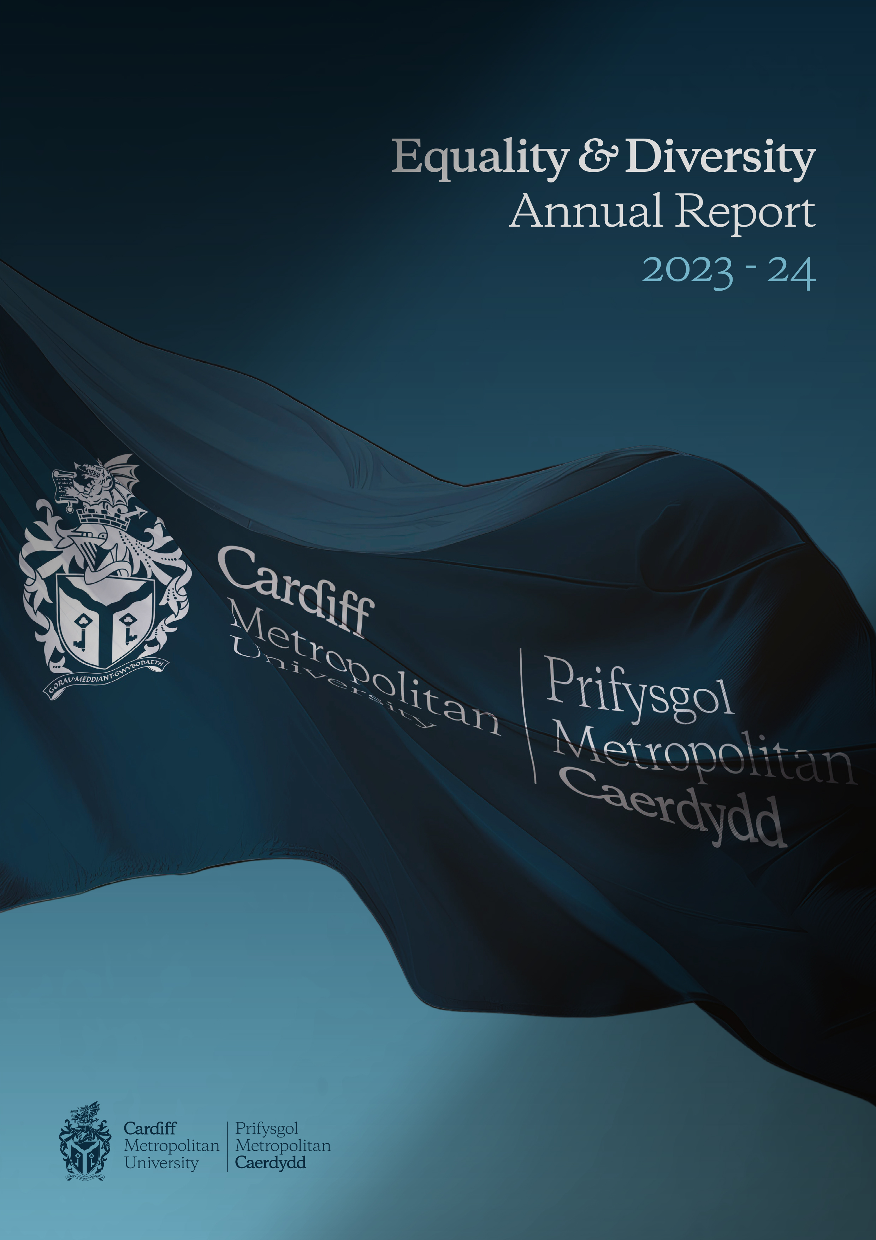

Foreword

On behalf of the University, I am pleased to present this year’s Annual Report, covering the period April 1st 2023 – March 31st 2024, providing the relevant monitoring data and outlining our ongoing work and commitment at Cardiff Met aimed at meeting our ambitions set out within our Strategic Equality Plan 2020-24.

This year's report brings to a close the annual reporting against our Strategic Equality Plan 2020-24. Our aspirations throughout the implementation of the plan have been to improve Cardiff Met’s equality and diversity profile, signalling our long-term commitment to champion equality of opportunity and promote effective and inclusive practice in Higher Education.

We look forward to continuing our work through the implementation of our Strategic Equality Plan 2024-28.

Professor Julia Longville
Chair of Equality, Diversity and Inclusion Committee
Dean for Cardiff School of Education and Social Policy


Introduction

The University places a great emphasis and value on Equality, Diversity and Inclusion (EDI) and we are committed to promoting and implementing best practice in EDI to provide a positive working and learning environment for our community.

We wish to ensure that Cardiff Met considers all aspects of equality, diversity and inclusion, ensuring that our policies and practices meet our statutory duties to support equality, diversity and inclusion, while also utilising sector best practice.

At Cardiff Met, we recognise the importance of the Welsh Language and are committed to ensuring that the Welsh and English languages are treated on a basis of equality when conducting our business in Wales. We aim to provide a culture where Welsh speaking staff, students and the public feel comfortable and confident in engaging with the University through the medium of Welsh.

Under the Specific Duties for Wales of the Equality Act 2010 Cardiff Met is required to produce a Strategic Equality Plan outlining equality objectives and to publish an annual monitoring report by the 31st March each year. The following report provides an overview of Cardiff Met’s equality data for the period 1st April 2023 – 31st March 2024. In a step-change from previous reporting periods and to ensure consistency across our data at Cardiff Met, we are utilising HESA staff and student 23/24 data.

EDI Governance at Cardiff Met

Board of Governors
The Board of Governors is made up of both external and internal members, with a lay majority; they have responsibility for the educational character and mission of our university, as well as having oversight of its activities.

Key functions of the Board include considering and approving our strategic plan, which sets our university's aims and objectives, and overseeing the financial, physical, and staffing strategies necessary to achieve this plan.

Academic Board
The Academic Board is a Committee of the Board of Governors and is responsible for advising the Vice-Chancellor and the Board of Governors. The Academic Board is both the University’s academic authority and its senior decision-making body for resources which support the University at a strategic level.

University Executive Group
The University Executive Group (UEG) membership consists of the senior leadership team of the University and assists the Vice-Chancellor.

Equality, Diversity and Inclusion Committee
The Equality, Diversity and Inclusion Committee’s aim is to promote and advance equality, diversity and inclusion across the University. The committee provides assurance to Academic Board on the execution of this responsibility and has oversight of the University's Strategic Equality Plan. The committee brings together key stakeholders from across the University to monitor progress in meeting the Equality Act 2010 general duty and other relevant equality legislation, ensuring the delivery of strategic targets and objectives.

Overview of staff data across the 2020-2024 reporting period

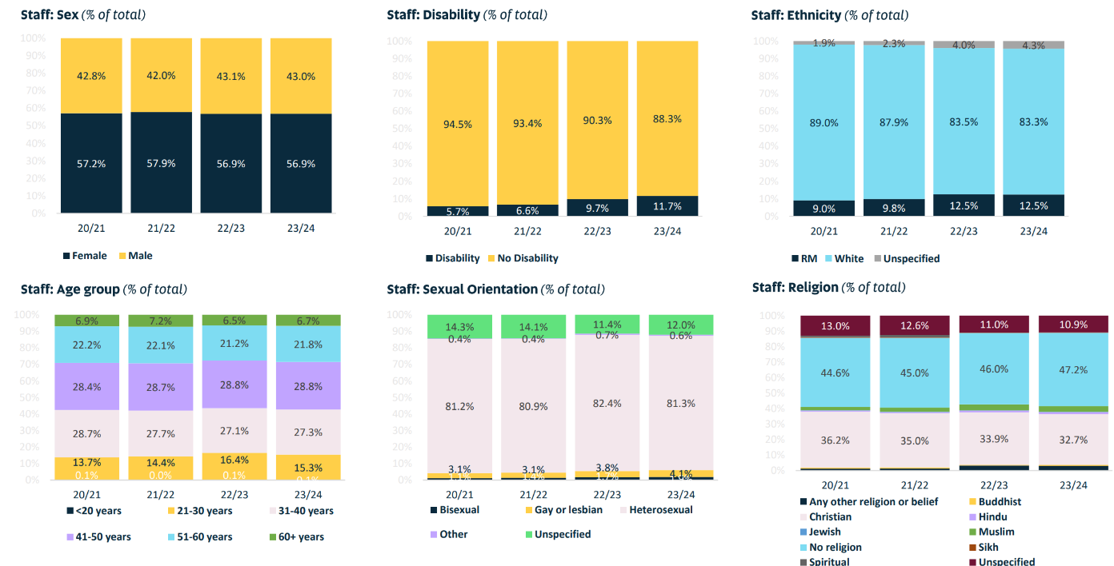

Staff Profile 'Snapshot' 2023-24
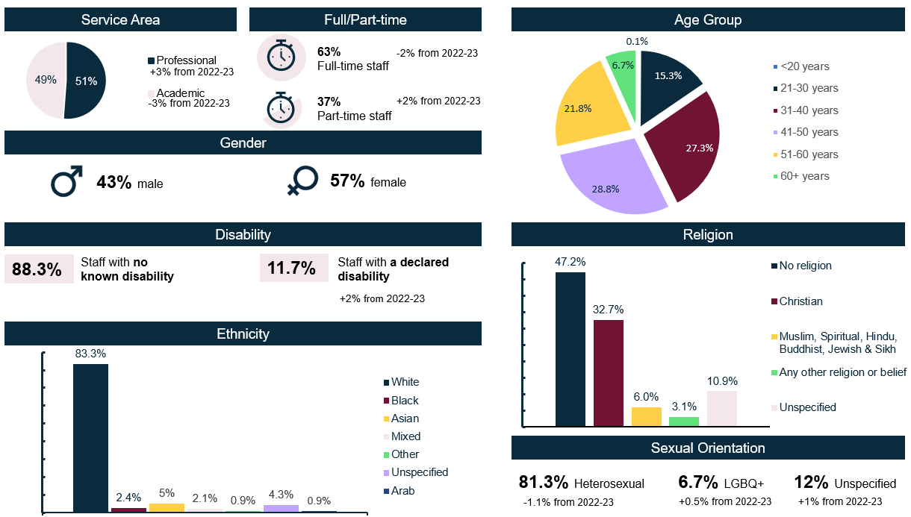

Student Profile 'Snapshot' 2023-24
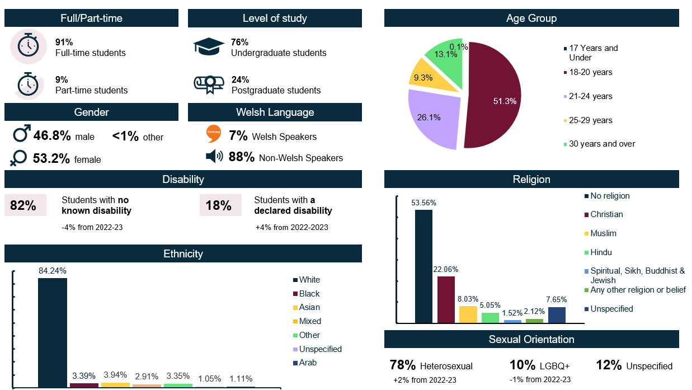

Sex Data 2023-24
Outer: Academic
Inner: Professional
Table 1: Sex of staff by function
 | Academic | Professional | Total
Male | 464 (47.3%) | 400 (38.9%) | 864
Female | 516 (52.7%) | 626 (61%) | 1142
Total | 980 | 1027 | 2007

Table 2: Sex of staff by grade
Grade* | Male | Female | Total
1A/1B | 16 (1.9%) | 36 (3.2%) | 52
2A/2B | 26 (3%) | 24 (2.1%) | 50
3A/3B | 42 (4.9%) | 99 (8.7%) | 141
4A/4B | 76 (8.8%) | 138 12.1%) | 214
5A/5B | 54 (6.3%) | 121 (10.6%) | 175
6A/6B | 114 (13.2% | 128 (11.2%) | 242
7A/7B | 241 (27.9%) | 266 (23.3%) | 507
8A/8B | 160 (18.5%) | 208 (18.2%) | 368
9A/9B | 73 (8.4%) | 82 (7.2%) | 155
Above grade 9 | 62 (7.2%) | 40 (3.5%) | 102
Total | 864 | 1142 | 2007

Table 3: Sex of staff by working pattern
 | Full-time | Part-time | Total
Male | 612 (47%) | 252 (35.7%) | 864
Female | 689 (52.9%) | 453 (64.3%) | 1142
Total | 1302 | 705 | 2007

Table 4: Sex of staff by contract type
 | Fixed-term | Permanent | Total
Male | 136 (42.4%) | 728 (43.2%) | 864
Female | 185 (57.6%) | 957 (56.8%) | 1142
Total | 321 | 1686 | 2007

Table 5: Sex of staff by leavers
Male | 46 (38%)
Female | 75 (62%)
Total | 121

Table 6: Sex of staff by Access to training
Male | 526
Female | 757
Total | 1283

Ethnicity Data 2023-24

Table 7: Ethnicity of staff by function
 | Academic | Professional | Total
White | 753 (77%) | 918 (89%) | 1671 (83%)
RM | 178 (18%) | 72 (7%) | 250 (12%)
Unspecified | 49 (5%) | 37 (4%) | 86 (4%)
Total | 990 | 1027 | 2007
Outer: Academic
Inner: Professional
Table 8: Ethnicity of staff by function (Breakdown)
 | Academic | Professional | Total
Arab | 14 (1.4%) | 5 (<1%) | 19 (1%)
Asian | 95 (9.7%) | 27 (2.6%) | 122 (6%)
Black | 34 (3.5%) | 15 (1.5%) | 49 (2%)
Mixed | 22 (2.2%) | 20 (1.9%) | 42 (2%)
Other | 13 (1.3%) | 5 (<1%) | 18 (1%)
Unspecified | 49 (5%) | 37 (3.6%) | 86 (4%)
White | 753 (76.8%) | 918 (89.4%) | 1671 (83%)
Total | 980 | 1027 | 2007

Table 9: Ethnicity of staff by sex
 | Male | Female | Total
Arab | 12 (1.4%) | 7 (<1%) | 19 (1%)
Asian | 62 (7.2%) | 60 (5.3%) | 122 (6%)
Black | 26 (3%) | 23 (2%) | 49 (2%)
Mixed | 11 (1.3%) | 31 (2.7%) | 42 (2%)
Other | 9 (1%) | 9 (<1%) | 18 (1%)
Unspecified | 39 (4.5%) | 47 (4.1%) | 86 (4%)
White | 705 (81.6%) | 965 (84.5%) | 1671 (83%)
Total | 865 | 1142 | 2007

Table 10: Ethnicity of staff by leavers
White | 99 (82%)
RM | 15 (12%)
Unspecified | 7 (6%)
Total | 121

Table 11: Ethnicity of staff by Access to training
Arab | 14
Asian | 104
Black | 36
Mixed | 29
Other | 5
Unspecified | 29
White | 1066
Total | 1283

Disability Data 2023-24

Table 12: Disability of staff by function
 | Academic | Professional | Total
Mental health condition | 23 (2%) | 33 (3%) | 56 (3%)
Specific learning difference | 47 (5%) | 36 (4%) | 83 (4%)
Other disability | 47 (5%) | 49 (5%) | 96 (5%)
No known disability | 811 (83%) | 855 (83%) | 1666 (83%)
Unspecified | 52 (5%) | 54 (5%) | 106 (5%)
Total | 980 | 1027 | 2007

Table 13: Staff disability profile
Disability | 235 (12%)
No Disability | 1772 (88%)
Total | 2007

Table 14: Disability of staff by leavers
Disability | 16 (13%)
No Disability | 105 (87%)
Total | 121

Table 15: Disability of staff by Access to training
Disability | 143
No Disability | 1042
Unspecified | 98
Total | 1283

Sexual Orientation Data 2023-24

Table 16: Sexual Orientation of staff by function
 | Academic | Professional | Total
Bisexual | 11 (1.1%) | 28 (2.7%) | 39 (2%)
Gay or lesbian | 45 (4.6%) | 38 (3.7%) | 83 (4%)
Heterosexual | 793 (80.9%) | 838 (81.6%) | 1631 (81%)
Other | <5 (0.4%) | 9 (0.9%) | 13 (1%)
Unspecified | 127 (13%) | 114 (11.1%) | 241 (12%)
Total | 980 | 1027 | 2007

Table 17: Sexual Orientation of staff by leavers
Bisexual | 5 (4%)
Gay or lesbian | 7 (6%)
Heterosexual | 88 (73%)
Unspecified | 21 (17%)
Total | 121

Table 18: Sexual Orientation of staff by Access to training
Bisexual | 30
Gay or lesbian | 54
Heterosexual | 1039
Other | 15
Unspecified | 144
Total | 1283

Age Data 2023-24

Table 19: Age of staff by function
 | Academic | Professional | Total
<20 years | - | <5 (0.2%) | <5 (<1%)
21 to 30 years | 92 (9.4%) | 216 (21%) | 308 (15%)
31 to 40 years | 256 (26.1%) | 291 (28.3%) | 547 (27%)
41 to 50 years | 316 (32.2%) | 262 (25.5%) | 578 (29%)
51 to 60 years | 233 (23.8%) | 204 (19.9%) | 437 (22%)
60+ years | 83 (8.5%) | 52 (5.1%) | 135 (7%)
Total | 980 | 1027 | 2007

Table 20: Age of staff by leavers
21 to 30 years | 36 (30%)
31 to 40 years | 38 (31%)
41 to 50 years | 15 (12%)
51 to 60 years | 20 (17%)
60+ years | 12 (10%)
Total | 121

Table 21: Age of staff by Access to training
Under 21 | 13
21 to 30 years | 216
31 to 40 years | 337
41 to 50 years | 365
51 to 60 years | 272
60+ years | 80
Total | 1283

Religion and Belief Data 2023-24

Table 22: Religion and Belief of staff by function
 | Academic | Professional | Total
Any other religion or belief | 26 (2.7%) | 37 (3.6%) | 63 (3%)
Buddhist | 10 (1%) | 2 (<1%) | 12 (1%)
Christian | 324 (33.1%) | 333 (32.4%) | 657 (33%)
Hindu | 18 (1.8%) | 7 (<1%) | 25 (1%)
Jewish | 3 (<1%) | <5 (<1%) | <5 (<1%)
Muslim | 60 (6.1%) | 15 (1.5%) | 75 (4%)
No religion | 415 (42.3%) | 533 (51.9%) | 948 (47%)
Sikh | <5 (<1%) | <5 (<1%) | <5 (<1%)
Unspecified | 121 (12.3%) | 98 (9.5%) | 219 (11%)
Total | 980 | 1027 | 2007
Table 24: Religion and Belief of staff by Access to training
Any other religion or belief | 16
Buddhist | 9
Christian | 413
Hindu | 22
Jewish | <5
Muslim | 61
No religion | 604
Not Available | 7
Prefer not to say | 119
Sikh | 5
Spiritual | 24
Total | 1283

Table 23: Religion and Belief of staff by leavers
Any other religion or belief | 5 (4%)
Christian | 33 (27%)
Muslim | <5 (3%)
No religion | 58 (48%)
Unspecified | 21 (17%)
Total | 121

Marriage & Civil Partnerships Data 2023-24

Table 25: Marital status of staff by function
 | Academic | Professional | Total
Co-habiting | 22 (2.2%) | 32 (3.1%) | 54 (3%)
Divorced/formerly in a civil partnership | 7 (<1%) | 11 (1.1%) | 18 (1%)
Married/civil partnership | 541 (55.2%) | 438 (42.6%) | 979 (49%)
Never married/registered in a civil partnership | 284 (29%) | 464 (45.2%) | 748 (37%)
Separated | 2 (<1%) | 4 (<1%) | 6 (<1%)
Unspecified | 122 (12.4%) | 77 (7.5%) | 199 (10%)
Widowed/surviving partner from civil partnership | <5 (<1%) | <5 (<1%) | <5 (<1%)
Total | 980 | 1027 | 2007
Table 27: Marital status of staff by Access to training
Co-habiting | 55
Divorced/formerly in a civil partnership | 13
Married/civil partnership | 603
Never married/registered in a civil partnership | 493
Separated | 115
Unspecified | <5
Widowed/surviving partner from civil partnership | <5
Total | 1283

Table 26: Marital status of staff by leavers
Co-habiting | <5 (3%)
Divorced/formerly in a civil partnership | <5 (<1%)
Married/civil partnership | 42 (35%)
Never married/registered in a civil partnership | 60 (50%)
Unspecified | 14 (12%)
Total | 121

Pregnancy & Maternity Data 2023-24

Maternity Leave
44 members of staff took maternity leave during the current report period.

Paternity Leave
No members of staff took Paternity Leave during the current reporting period.

Parental Leave
1 member of staff took Parental Leave during the current reporting period.

Adoption Leave
1 member of staff took Adoption Leave during the current reporting period.

Shared Parental Leave
No members of staff took Shared Parental Leave during the current reporting period.

Training
29 members of staff on Maternity leave undertook training during the reporting period.

Gender Reassignment Data 2023-24

Table 27: Gender Reassignment staff overview
Gender identity same as sex registered at birth | 1635 (81.5%)
Gender identity different to sex registered at birth | 18 (<1%)
Unspecified | 354 (17.6%)
Total | 2007

Table 28: Gender Reassignment of staff by leavers
Gender identity same as sex registered at birth | 84 (69.4%)
Gender identity different to sex registered at birth | <5 (2.5%)
Unspecified | 34 (28.1%)
Total | 121

Table 29: Gender Reassignment of staff by Access to training
Gender identity same as sex registered at birth | 856
Gender identity different to sex registered at birth | 54
Unspecified | 373
Total | 1283

Staff Recruitment Data 2023-24

Recruitment activity such as the use of head hunters, agencies etc is not counted within the tables below.

Table 30: Progression through recruitment stages
 | Ethnicity |  |  | Sex |  | Disability |  | Sexual Orientation
 | White | RM | Unspecified | Male | Female | No Disability | Disability | LGBQ+ | Heterosexual
Applications | 2382 (51% | 2202 (47%) | 87 (2%) | 2275 (49%) | 2358 (51%) | 4335 (93%) | 336 (7%) | 487 (11%) | 3811 (89%)
Interviews | 687 (67%) | 316 (31%) | 20 (2%) | 414 (41%) | 599 (59%) | 932 (91%) | 91 (9%) | 105 (11%) | 835 (89%)
Appointed | 309 (72%) | 114 (26%) | 8 (2%) | 156 (36%) | 272 (64%) | 387 (90%) | 44 (10%) | 50 (13%) | 341 (87%)

Table 31: Progression through recruitment stages – Gender Reassignment
 | Gender identity same as sex registered at birth | Gender identity different to sex registered at birth | Unspecified
Applications | 3499 (75%) | 70 (1%) | 1102 (24%)
Interviews | 647 (63%) | 11 (1%) | 365 (36%)
Appointed | 238 (55%) | <5 (1%) | 190 (44%)

Table 32: Progression through recruitment stages – Religion and Belief
 | Any other religion or belief | Buddhist | Christian | Hindu | Jewish | Muslim | No Religion | Sikh | Spiritual | Unspecified
Applications | 76 (2%) | 92 (2%) | 1257 (27%) | 475 (10%) | 8 (<1%) | 570 (12%) | 1756 (38%) | 21 (<1%) | 74 (2%) | 342 (7%)
Interviews | 18 (2%) | 12 (1%) | 264 (26%) | 53 (5%) | <5 (<1%) | 87 (8%) | 485 (47%) | <5 (<1%) | 17 (2%) | 92 (9%)
Appointed | 6 (2%) | 4 (1%) | 104 (24%) | 23 (5%) | <5(<1%) | 19 (5%) | 220 (51%) | <5 (<1%) | 6 (1%) | 47 (11%)

Table 33: Progression through recruitment stages – Sexual Orientation
 | Bisexual | Gay | Heterosexual | Lesbian | Other | Unspecified
Applications | 278 (6%) | 105 (2%) | 3811 (82%) | 64 (1%) | 40 (1%) | 373 (8%)
Interviews | 54 (5%) | 20 (2%) | 835 (82%) | 19 (2%) | 12 (1%) | 83 (8%)
Appointed | 27 (6%) | 9 (2%) | 341 (79%) | 10 (3%) | <5 (1%) | 40 (9%)

Table 34: Progression through recruitment stages – Age
 | <21 | 21-30 | 31-40 | 41-50 | 51-60 | 60+ | Unspecified
Applications | 103 (2%) | 2197 (47%) | 1302 (28%) | 657 (14%) | 317 (7%) | 87 (2%) | 8 (<1%)
Interviews | 39 (4%) | 433 (42%) | 277 (27%) | 171 (17%) | 87 (9%) | 14 (1%) | <5 (<1%)
Appointed | 26 (6%) | 191 (44%) | 106 (25%) | 64 (15%) | 38 (9%) | 5 (1%) | <5 (<1%)

Grievances and Disciplinaries 2023-24

Only formal grievances are recorded within People Services as a full and fair procedure in line with the ACAS Code must be followed for any formal grievance raised. The procedure followed will be taken into account if the case reaches an employment tribunal.

In comparison to 2022/2023 in which six grievances were received, in 2023/24 there were four formal grievances raised. Two were in relation to an alleged failure to follow a fair procedure, one was in relation to harassment, and one was in relation to bullying.

In terms of outcomes and resolution, 1 grievance was withdrawn, 1 was resolved informally, 1 was not upheld, and 1 is still ongoing. People Services continue to monitor all cases and assess for any wider EDI issues.

Due to maintaining data confidentiality we are unable to provide any details on the individuals who raised the grievances, or the specifics of the grievances raised. This is in line with GDPR requirements and Statistical Disclosure best practice.

Appendices

Appendix 1 – Compliance Information

Appendix 2 – Strategic Equality Plan 2023-24 Progress

Equality, Diversity and Inclusion Team

 | Martin Smith  Equality & Diversity Officer  mrsmith@cardiffmet.ac.uk
Alysean Banks
EDI Project Coordinator
abanks@cardiffmet.ac.uk

General Enquiries: equality@cardiffmet.ac.uk
Website: Cardiff Metropolitan University - Study in Cardiff


`

