
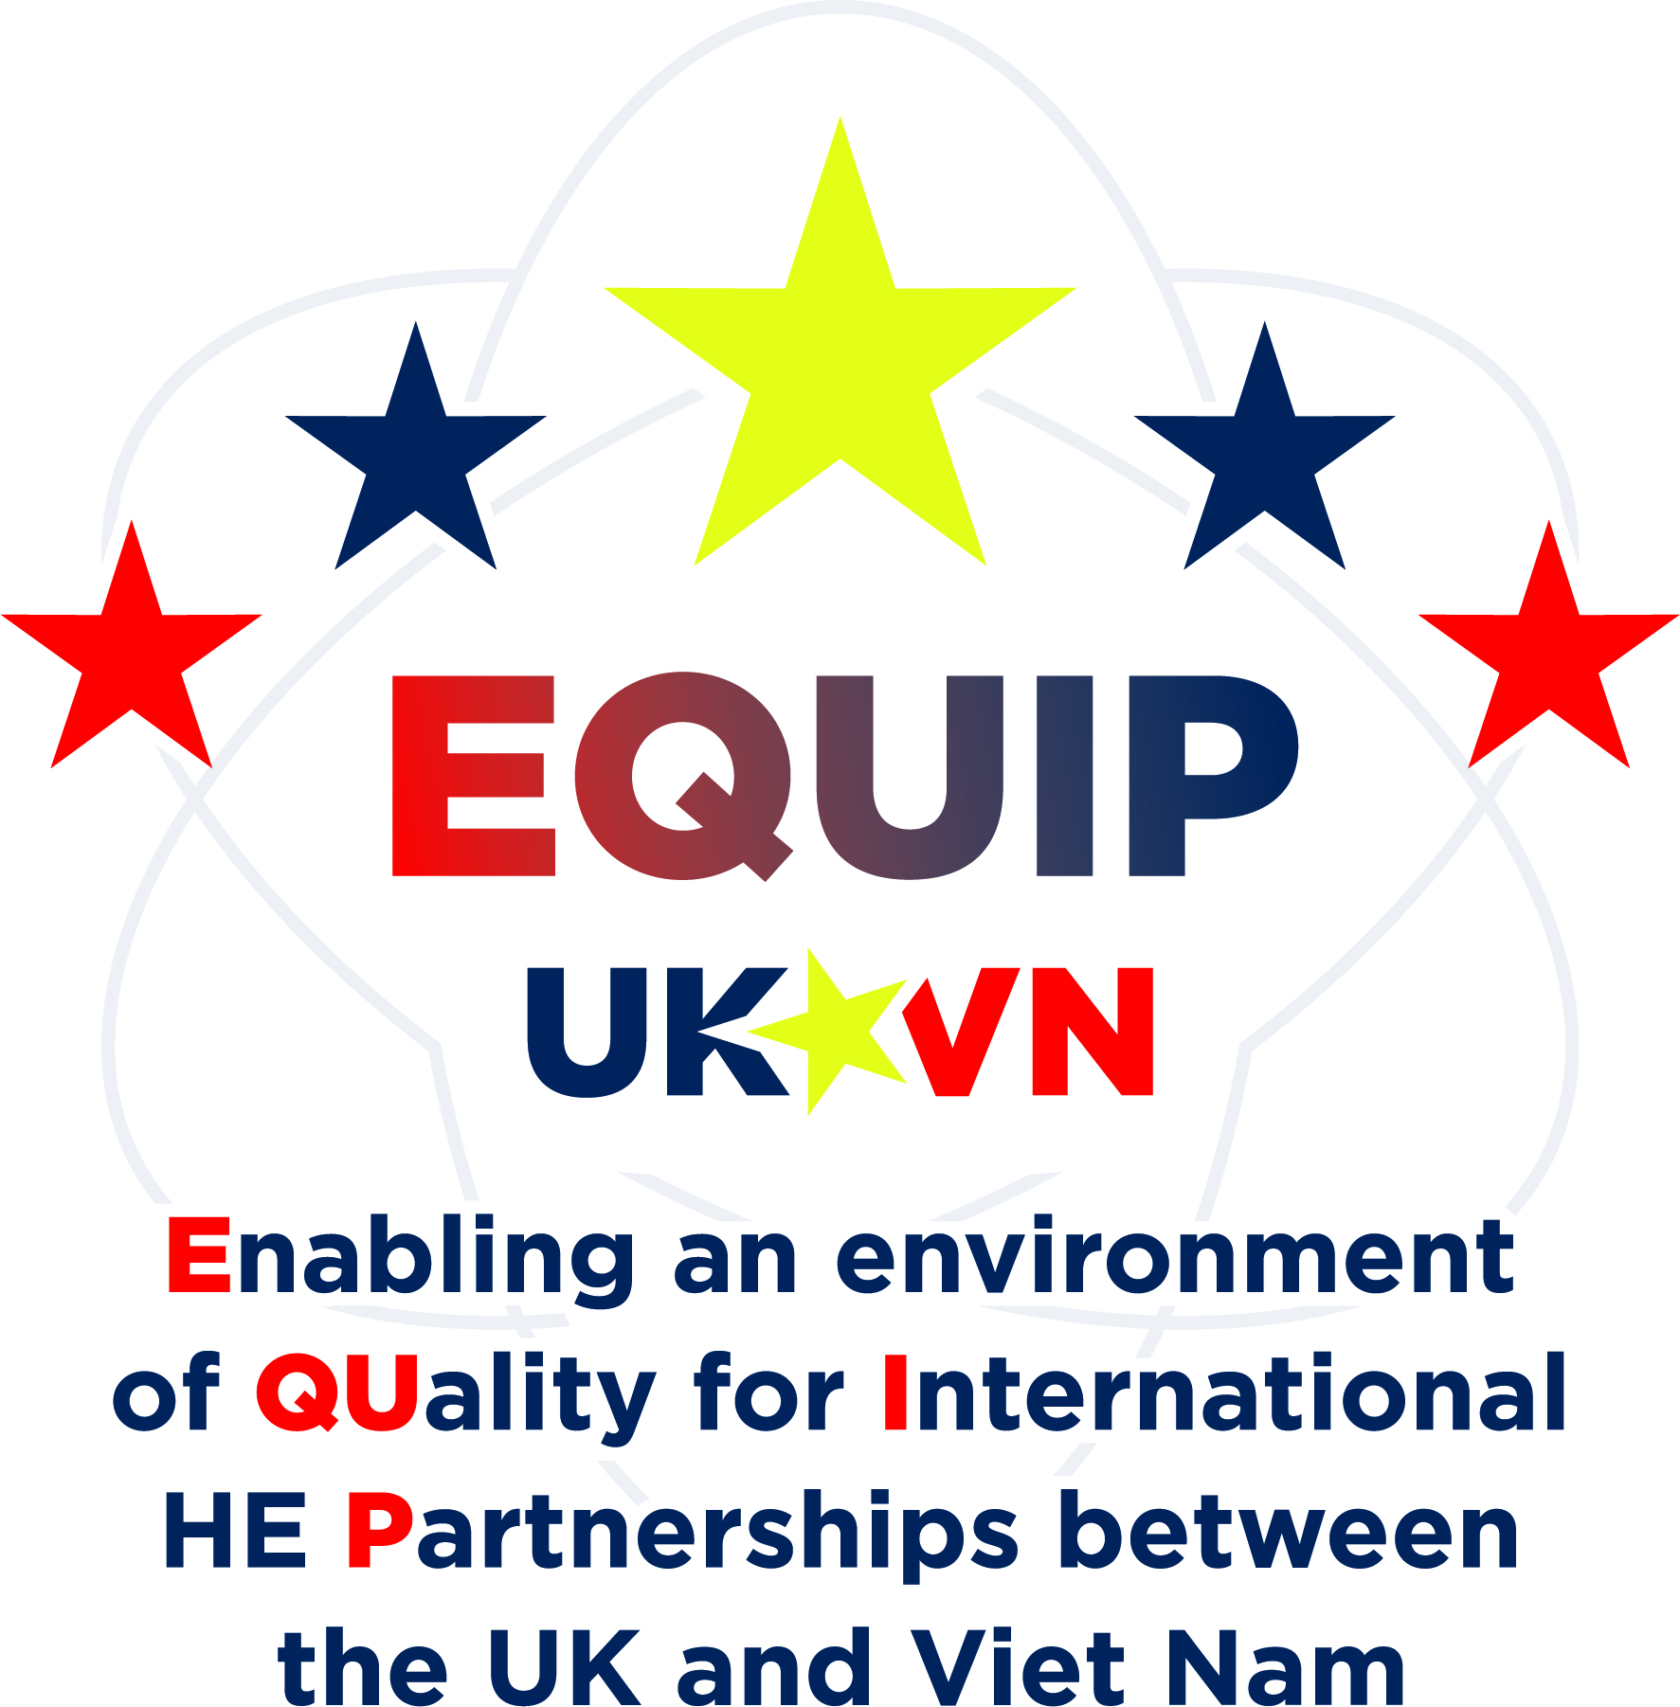


Pre-reading relating for Day 2 session of the Equip Project training.
Programme Design & Curriculum

In preparation for the session on Programme Design & Curriculum participants are required to complete the following activities so they are prepared to contribute to the interactive tasks that have been embedded in the sessions:

Activity 1 - Seec level descriptors
Please download and read through the Seec level descriptor document:

SEEC-Credit-Level-Descriptors-2021.pdf

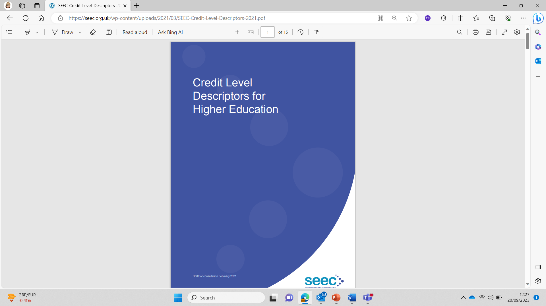

Activity 2 - Constructive Alignment
Watch the short video (link below) on constructive alignment and take notes.
Be ready to share your thoughts on this video and to raise any questions you might have.

Short video about Constructive Alignment

Activity 3 - Constructive Alignment
Watch another short video (link below) on constructive alignment and take notes.
Be ready to share your thoughts on this video and to raise any questions you might have.

Another short video about Constructive Alignment​

Activity 4 - Constructive Alignment
Please would each participant identify a module (any level) and bring a hard copy or have a digital file- available for their reference during the training.

