Welcome Week Handbook

0

MSc Digital Marketing Management

Cardiff School of Management



# Contents

**Introduction**2

|  |  |
| --- | --- |
| **Essential Information** | 4 |
| **Meet the Team** | 8 |
| **Welcome Week** | 9 |
| **Useful Information** | 14 |

1

# Introduction

## Welcome Message

Starting University is very exciting. We have put together a series of activities and events to help you settle into your academic programme and get to know the University, your course and your new colleagues.

The aim, therefore, of Welcome Week is to provide you with an opportunity to get involved with your chosen course of study right from the start.

During Welcome Week you will be involved in a range of inquiry-based projects (please see the section on programme activities and projects for more details) designed to provide you with a taste of what you can expect during your studies at Cardiff Met.

## Welcome Week Objectives

During Welcome Week you will be required to:

1. Meet your Programme Director, teaching team and the rest of your cohort
2. Attend social activities and events on campus or online
3. Engage in a research-based task
4. Complete a problem-solving activity

2

## Programme Director

Dear Future, Digital Professional!

Welcome to the MSc Digital Marketing Management course at Cardiff Metropolitan University. You are about to join a great community of like-minded students and graduates who are all passionate about studying Digital! You will spend this year immersed in the industry, and academia honing your creative, visual, digital and analytical skills and cutting your teeth on industry focused briefs and projects.

Our degree has been developed in conjunction with industry consultants and **Digital Marketing Institute (DMI) accredited,** so you can be confident that your degree is of professional standards and helps you to develop cutting edge techniques that will be relevant in the digital industry. You are encouraged to read the latest digital industry news and to bring these into our vibrant class sessions for discussion and debate. As a course we are focused on creating opportunities for you to be part of a wider community, students are currently actively participating and interested in starting a Digital Society which will be home to events and guest speakers to give you a start with your Digital network.

We have our own Instagram @Csmdigitalmarketing where you can be involved in curating our social media content and keeping the group informed about what is happening throughout the course. Induction Week will start on Monday 18th September 2023 and we have put together a series of activities to help you get to know the University, your programme of study, others on your course and the staff who will be teaching you. It is important that you take an active part in your induction week as you will be given a range of important information about studying at Cardiff Met.

Every new student is allocated a Personal Tutor who will support you throughout your Cardiff Met journey. Providing high quality support to you is important to us and you will meet your personal tutor during Induction Week. If you would prefer a Welsh speaking Personal Tutor, please let me know before you arrive so I can arrange this for you. We also have a range of existing opportunities available for you during your studies, including: Work Placements, CIM Student Chapter, Enhancement Activities, Language clubs, Volunteering

3

opportunities. We also have several sports teams and societies waiting for you to join them. Please make sure you enrol in the induction week as this will allow you to access our systems and get your student card. The card gives you access to various facilities around campus; it also allows you to make use of the facilities in the library. I very much look forward to meeting you on Tuesday 19thSeptember 2023. For more information about induction week please go to [www.cardiffmet.ac.uk/newstudents.](http://www.cardiffmet.ac.uk/newstudents)

See you soon!

### Dr Tahir Mushtaq

Programme Director - MSc Digital Marketing Management [**tmushtaq@cardiffmet.ac.uk**](mailto:tmushtaq@cardiffmet.ac.uk)

4

# Essential Information

## Programme Details

The programme is offered as a one-year, full-time programme and three years, part-time programme. The programme is modular in design. To obtain MSc Digital Marketing Management, each student will be required to successfully complete a total of 180 credits; this is comprised of six 20 credit modules and one 60 credit dissertation, or seven 20 credit taught modules, and one 40 credit marketing plan module. The taught element for the full- time programme is offered over two Semesters, where students will study three/four modules in Semester 1 and three/four modules in Semester 2 depending on the intake. The students will complete their final project/dissertation in Semester 3. The standard School Semester duration is normally 12 weeks. The MSC Digital Marketing programme is officially accredited by Digital Marketing Institute (DMI) and successful completion of the programme with 120 credits merits a certificate at associate level from DMI.

Part-time students will follow the same structure as the full-time programme; however, they would select modules as appropriate to their own pace of learning.

A 20-credit module represents 200 hours of student effort, while the 40 credit module represents 400 hours of student effort. To achieve the Master’s level qualification, students must achieve 180 credits at Level 7.

The overall mark for the master’s level qualification shall be calculated on the basis of the average of the marks for all modules weighted according to the credit values of those modules. A student may achieve a Master’s degree with Distinction if he/she has achieved an overall mark of not less than 70%. A student may achieve a Master’s degree with Merit if he/she has achieved an overall mark between 60% and 69%.

A candidate who is admitted to the Master’s scheme but is subsequently unable to achieve the full Masters level qualification may be awarded as follows:

Credits at Level 7 Candidates may exit with:

Not fewer than 60 Postgraduate Certificate

5

Not fewer than 120 Postgraduate Diploma

120 Credits Certified Digital Marketing Associate (CDMA) from DMI

180 Credits MSC Digital Marketing Degree

**The MSC Digital Marketing offers two yearly intakes: September Intake (Main Intake and January Intake)**

**September Intake Course Structure:**

**Semester 1:**

|  |  |  |  |
| --- | --- | --- | --- |
| **Module Code** | **Module Title** | **Semester\*** | **Credit Value** |
| DMM7011 | Contemporary Trends in Digital  Marketing | S1 | 20 |
| DMM7004 | Multi-channel Digital Marketing | S1 | 20 |
| DMM7010 | Digital Content Creation and Copywriting | S1 | 20 |
| *Award – PG Certificate* | |  | 60 |

# **Semester : 2**

|  |  |  |  |
| --- | --- | --- | --- |
| **Module Code** | **Module Title** | **Semester\*** | **Credit Value** |
| DMM7001 | Consumer Behaviour – Knowing Your Digital Consumer | S2 | 20 |
| DMM7002 | Digital Analytics & Insights - Web, Mobile and Marketing | S2 | 20 |
| MKT7003 | Modern Marketing Research | S2 | 20 |
| MKT7009 | Marketing Internship (Optional) | S2 | 20 |
| MSM7044 | In Search of Creativity, Innovation & Difference (Optional) | S2 | 20 |
| *Award – PG Dip + CDMA from DMI* | |  | 120 (min) |

**Semester 3:**

|  |  |  |  |  |  |
| --- | --- | --- | --- | --- | --- |
| **Module Code** | **Module Title** | **Semester\*** | **Credit Value** | **Shared Module** | **Short Course** |
| DMM7008 | Digital Dissertation | S3 | 60 | No | No |
| DMM7012 | Marketing Plan in a Digital  Context | S3 | 40 | No | No |
| *Award – Masters*  **Final Award – MSc *Digital Marketing Management*** | |  | 180 |  | |

**January Intake Course Structure:**

# **Semester 1:**

|  |  |  |  |
| --- | --- | --- | --- |
| **Module Code** | **Module Title** | **Semester\*** | **Credit Value** |
| DMM7001 | Consumer Behaviour – Knowing Your Digital Consumer | S2 | 20 |
| DMM7002 | Digital Analytics & Insights - Web, Mobile and Marketing | S2 | 20 |
| DMM7004 | Multichannel Digital Marketing | S2 | 20 |
| MKT7009 | Marketing Internship (Optional) | S2 | 20 |
| MSM7044 | In Search of Creativity, Innovation & Difference (Optional) | S2 | 20 |
| *Award – PG Certificate* | |  | 60 (min)  80 (max) |

**Semester 2:**

|  |  |  |  |
| --- | --- | --- | --- |
| **Module Code** | **Module Title** | **Semester\*** | **Credit Value** |
| DMM7011 | Contemporary Trends in Digital  Marketing | S1 | 20 |
| MKT7003 | Modern Marketing Research | S1 | 20 |
| DMM7010 | Digital Content Creation and Copywriting | S1 | 20 |
| *Award – PG Dip + CDMA from DMI* | |  | 120 (min)  140 (max) |

**Semester 3:**

|  |  |  |  |  |  |
| --- | --- | --- | --- | --- | --- |
| **Module Code** | **Module Title** | **Semester\*** | **Credit Value** | **Shared Module** | **Short Course** |
| DMM7008 | Digital Dissertation | S3 | 60 | No | No |
| DMM7012 | Marketing Plan in a Digital  Context | S3 | 40 | No | No |
| *Award – Masters*  **Final Award – MSc *Digital Marketing Management*** | |  | 180 |  | |



## Part-Time Students

Whilst full-time students should participate in everything, we recognise that you may not be able to do so because of your other commitments, and we understand this.

Talk with your Personal Tutor about which activities will be most valuable for you and see what you can manage. You will be welcome to join in all events during the week, as and when you can. Do, though, ensure that you have registered, and done the required paperwork before attending any events.

## International Students

We understand that international students will have many obligations and paperwork to complete when they arrive in the U.K and The Global Student Advisory Service offers support to international students at Cardiff Met by providing support pre-arrival and throughout their studies.

Global Student Advisory Support [International - Welcome (sharepoint.com)](https://outlookuwicac.sharepoint.com/sites/international/SitePages/Welfare/home.aspx)

[Global Student Advisory Service International Welfare Advice](https://www.cardiffmet.ac.uk/international/currentstudents/Pages/International-Welfare-Advice.aspx) [International Academic Advice International Academic Advice](https://www.cardiffmet.ac.uk/international/currentstudents/international-academic-advice/Pages/default.aspx)

Global Student Advisory Contacts

Welfare Advice – [intstudentadvice@cardiffmet.ac.uk](mailto:intstudentadvice@cardiffmet.ac.uk) Immigration Advice - [Immigrationregs@cardiffmet.ac.uk](mailto:Immigrationregs@cardiffmet.ac.uk)

International Academic Advice – [intacademicadvice@cadiffmet.ac.uk](mailto:intacademicadvice@cadiffmet.ac.uk)

7

It is also important that you attend the activities planned for your course during Welcome Week, so you get to meet your Programme Directors, Tutors and the rest of your cohort. This will help you to settle into your new environment and make new friends.

### Term Dates: Sep 2023/2024

### <https://outlookuwicac-my.sharepoint.com/:b:/g/personal/sm23495_cardiffmet_ac_uk/EUL-Z63Yt2lJlQ1OoDR1EaMBS-aleFgwTnNgJTr2IzoCvw?e=heEFG6>

Meet The Team:

|  |  |
| --- | --- |
| Dr Tahir Mushtaq  Senior Lecturer in Digital Marketing  [TMushtaq@cardiffmet.ac.uk](mailto:TMushtaq@cardiffmet.ac.uk)  Dr Tahir is an experienced Lecturer with a demonstrated history of working in the Higher Education Industry. Skilled in Digital Content Creation, Neuro and Contemporary Marketing Practices, Data Analytics, Market Research, Digital Consumer Behaviour, Statistical Analysis, Digital and Social Media Marketing. Strong education professional with a Doctor of Philosophy (PhD) in Marketing from Swansea University. |  |
| Lisa Davies  Lecturer in Digital Marketing  [LCDavies@cardiffmet.ac.uk](mailto:LCDavies@cardiffmet.ac.uk)  Lisa Davies is a lecturer in Digital Marketing Management with Cardiff Metropolitan University, committed to practice-focused, professionally orientated education. With thirty years’ experience in marketing and design, across public and private sector, B2B and B2C, Lisa has the industry knowledge and skills to enable students to fulfil their potential in the competitive marketing workplace. Before joining academia in 2019 Lisa held roles in Brand and Marketing Management, Graphic Design and Studio Management for leading FMCG, SaaS and interactive TV companies. Lisa is approved by the Chartered Institute of Marketing (CIM) to teach Digital Marketing at Levels 4 and 6. |  |
| Rumana Faruque  Lecturer in Digital Marketing  [RFaruque@cardiffmet.ac.uk](mailto:RFaruque@cardiffmet.ac.uk)  Rumana is passionate academic. She has years of experience in several academic industries both in UK & USA. Her passion lies in integrating private sector experience into academia and bring out a blended version of interactive teaching methods. Her core interest lies in Digital Technology and Digital Marketing covering areas like Digital and Social Media Marketing; Google Analytics and Google Ads; Search engine optimisation (SEO); Search engine marketing (SEM); Brand awareness; Conversion rates and Content writing. | Photo of Rumana Faruque |
| Dr Dan Zhang  Lecturer in Digital Marketing  [dzhang@cardiffmet.ac.uk](mailto:dzhang@cardiffmet.ac.uk) |  |
| Dr Onder Kethuda  Lecturer in Digital Marketing  [okethuda@cardiffmet.ac.uk](mailto:okethuda@cardiffmet.ac.uk) |  |

# Welcome Week

## What to expect

During the week you will complete a small inquiry-based project, which you will undertake with a group of other new students from your programme, supported by academic and technical staff and an existing student or two.

At the end of the week, we will also give you some feedback on the strengths of your group’s approach, sharing and celebrating what we have discovered together.

There will be an introduction to your new School and Programme and lots of fun activities to help you meet new people.

You will also need to complete a bit of administration, check-in so that we know who is doing what and when, complete any outstanding registration matters, pick up University ID and Students’ Union cards, complete papers to help ensure your safety, and touch base with any specialised support services that you need.

Here’s what Cardiff Met students enjoyed about Welcome Week

*“Helped me settle in and took the pressure off travelling to a new place”*

*“The group projects to find out about our peers was a nice way of getting to know everyone”*

*“Helpful to chat informally to the Programme Director and chat about random things to help settle in”*

10

## Programme Activities and Projects

Your journey through university will be what you make it, staff will be there to guide you throughout your time, but this really does start with you.

There is no doubt that the impact of COVID-19 and the ensuing lockdown measures around the world has changed many of the ways in which the world operates. The Digital industry has also seen many changes throughout this period, and these impacts are likely to change the way forever. While many of these impacts were likely to come eventually, the pandemic has certainly escalated some of the issues, and exposed some of the ways the Digital industry works (both good and bad). Your induction presentation brief is therefore to explore the many ways in which the pandemic has impacted the industry. You are requested to read widely, explore brands own social media communications and websites, as well as news and academic articles discussing how this will change the industry.

The marketing week editor Russell Parsons, Direct Line Group head of commercial marketing Sam Taylor, The Ozone Project chief revenue officer Craig Tuck and Zoe Harris, CMO of Gocompare and CEO of its Autosave business, discussed the crisis’s impact on the use of digital, trust levels and brand safety is a good starting point.

https://[www.marketingweek.com/coronavirus-crisis-impact-digital-marketing/](http://www.marketingweek.com/coronavirus-crisis-impact-digital-marketing/)

In light of the discussion and your own research please focus on the following areas; -

1. Brands communications through the pandemic – what kinds of things were they putting on their social media?
2. Key themes, types of imagery etc.
3. How have consumers habits changed? Is this likely to be a permanent change? 4) How has the pandemic impacted trends? - Or anything else you find interesting.

You are requested to create a visual presentation detailing your research. You will be presenting this on Thursday in Induction Week.

11

## Social Activities

You will find information about activities planned through your course in the induction week timetable included in this guide.

Please check the information from the Student's Union for any additional social activities running throughout the week.

## Freshers’ Fayre

The Freshers’ Fayre, organised by the Students’ Union, is your first chance to meet to all our SU Societies, SU Sports Teams and of course a chance to grab all manner of freebies from our commercial partners! The fayre is an all-day event taking place on 25th January 2023 within NIAC on the Cyncoed campus! It is one of the highlights of the Freshers calendar and one of the only times during your university journey that every student from all Cardiff Met schools will be in the same place!

Head over to the Cardiff Met Students’ Union website for up-to-date information on events, societies, support and more.

12

|  |  |  |  |  |
| --- | --- | --- | --- | --- |
| Your Welcome Week Timetable – MSc Digital Marketing Management: January 2024 | | | | |
| **MONDAY 22 January** | **TUESDAY 23rd January** | **WEDNESDAY 24TH** **SEPTEMBER** | **THURSDAY 25th January** | **FRIDAY 26th January** |
| Please make sure to enroll and obtain your MET student ID.  If you have not done so already, you need to enrol at [Enrolment (cardiffmet.ac.uk)](https://www.cardiffmet.ac.uk/study/newstudents/Pages/Enrolment.aspx). Get your Cardiff Met student card | 11:00am – 1:00pm –  Welcome to Cardiff Met and CSM: Main Induction Session and Campus Tours  1pm – 2pm  Lunch Break  2:00pm – 4:00pm –  Ice Breaking session and Activities | Fresher Events (Student Union) | 2:00pm – 4:00pm –  Personal Tutor Meetings: you must book these in advance. Please contact [TMushtaq@cardiffmet.ac.uk](mailto:TMushtaq@cardiffmet.ac.uk) | 11:00am – 1:00pm –  **For later joiners: Induction and Welcome**  Please only come to the above-mentioned room: (If you were unable to attend the Main Induction session on Tuesday)  **Time to settle in:**  Additional Online Courses:  Register with a doctor for  emergencies (it’s free for students) near where you live  [GP Surgeries - Cardiff and](https://cavuhb.nhs.wales/hospitals-and-health-centres/local-health-services/gp-surgeries/) [Vale University](https://cavuhb.nhs.wales/hospitals-and-health-centres/local-health-services/gp-surgeries/) [Health Board](https://cavuhb.nhs.wales/hospitals-and-health-centres/local-health-services/gp-surgeries/) [(nhs.wales)](https://cavuhb.nhs.wales/hospitals-and-health-centres/local-health-services/gp-surgeries/)  Book yourself into one or more of the academic and digital skills workshops – they are very useful for current and new students  [MetHub(cardiffmet.ac.uk)](https://methub.cardiffmet.ac.uk/students/events/Type/25/learning-support-workshop) |

## Personal Welcome Week Checklist

During Welcome Week you need to make sure that you have completed the following tasks:

* + Complete enrolment process
  + Collect student ID card
  + Attend programme activity session
  + Attend some social events on campus/online
  + Attend Fresher’s Fayre
  + Meet your Programme Team
  + Take part in the Met Mile Walk
  + Familiarise yourself with the Library and Student Support Services

14



# Useful Information

## New Students Information

The [Course Joining Information website](https://www.cardiffmet.ac.uk/study/newstudents/Pages/default.aspx) has lots of useful information

to help with your planning. Simply select your level of entry on the website to find out more.

## Student Services

[Student Services](https://www.cardiffmet.ac.uk/study/studentservices/Pages/default.aspx) provide support and guidance, including counselling and mental health, disability support, and money management.

## SU Welcome Guide

An interactive guide to help you navigate your journey into and throughout your university life. Take the tour and enjoy each section designed to help you get to know Cardiff Met.

[What you need to know before you go](https://www.cardiffmetsu.co.uk/what_to_know_before_you_go/)



## Academic Calendar 2022/23

[Academic Calendar 2022/2023](https://www.cardiffmet.ac.uk/registry/Documents/Term%20Dates%202022-2023%208.4.22.pdf)

15

## Campus Map

**Llandaff Campus**

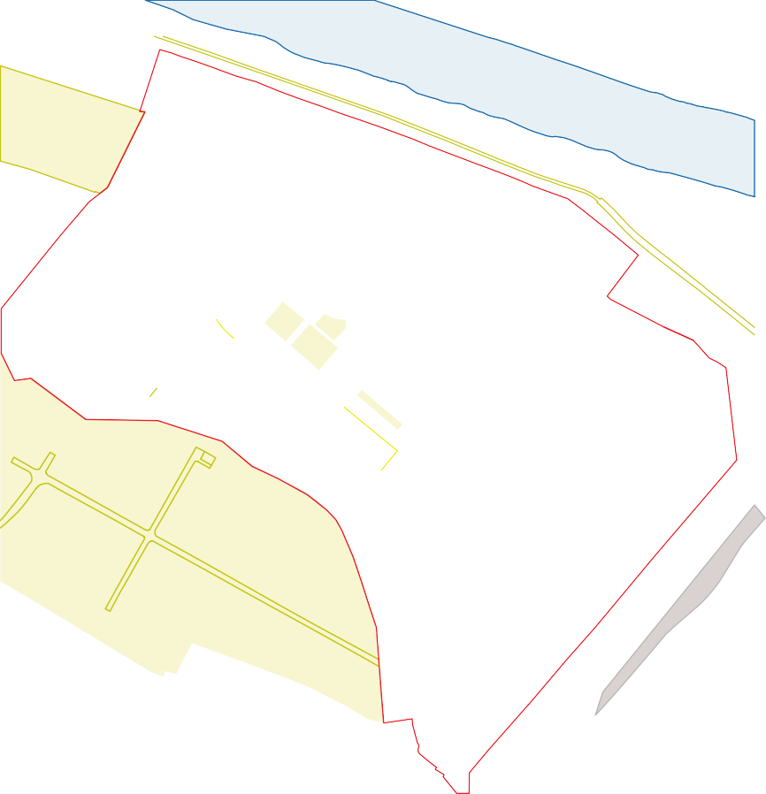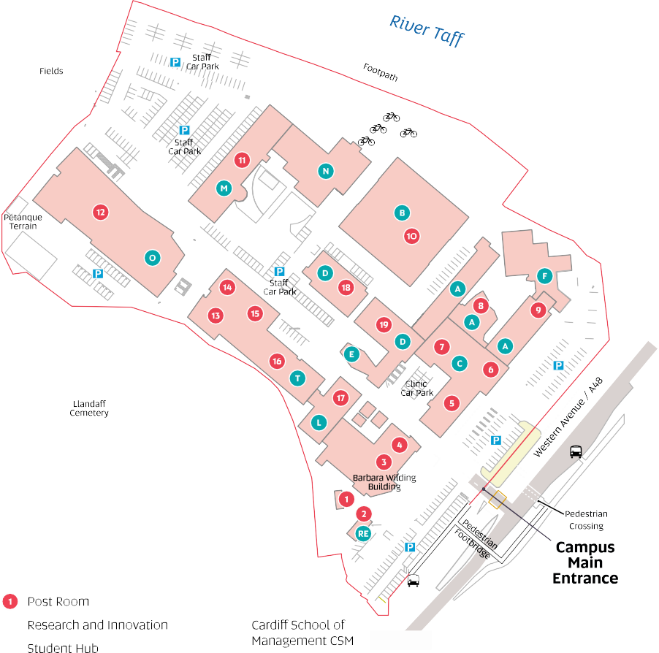

Gym (First Floor) IT Help Desk

Podiatry School of

Dental Technology

Main Reception & i-Zone Global Engagement

Main Halls Biomedical

Lecture Theatre A0.31 Sciences CSSHS Parking

Cardiff School of Learning Centre Bike Rack

Technologies CST Food Industry Bus Stop

Cardiff School of Art Centre FIC **2** • City Circle

and Design CSAD School of Health **15** · Heath Hospital

Maritime House Sciences CSSHS to Central Station

16

## Useful Contact Numbers

Accommodation Services – 029 2041 6188/9

Enrolment – 029 20 205669

Finance & Tuition Fees – 029 20 41 6083/6081

Home Admissions – 029 2041 6010

International Admissions – 029 20 41 6045

IT Helpdesk – 029 20 41 7000

I-Zone Cyncoed – 029 2020 5460

I-Zone Llandaff – 029 2020 5600

Learning Centre Cyncoed – 029 20 41 6242

Learning Centre Llandaff – 029 20 41 6244

Switchboard – 029 20 41 6070

Sports Facilities – 029 20 41 6042

Student Service – 029 20 41 6170

Students Union – 029 20 41 619

17