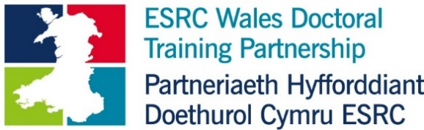
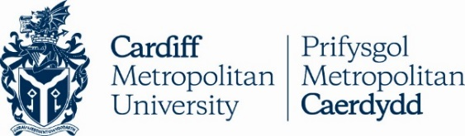

Cardiff Metropolitan University, School of Sport and Sciences, supported by the ESRC Wales Doctoral Training Partnership (ESRC Wales DTP) and in collaboration with Swansea University and The Living Room Cardiff, invites applications for a fully funded PhD studentship to commence in October 2018, with the following title:

The role of sport in the manifestation and treatment of addictive behaviours

The research programme will involve close collaboration with The Living Room Cardiff and aims to explore the relationship between participation in sport and addictive behaviour. The project will examine how hereditary, personality, environmental and cultural factors operate before and during active addiction in various sports contexts. There will also be a focus on the concept of ‘recovery capital’ and sport’s role therein. The successful applicant will have a strong background in addiction studies, social psychology, sociology or philosophy and an interest in understanding addictive behaviour. An aptitude for advanced qualitative methods is also essential. The project will be supervised by a team led by Professor Carwyn Jones (Cardiff Met), and includes Dr Camilla Knight (Swansea University).

The School of Sport and Health Sciences is internationally recognised for the quality of its research and provides an outstanding environment for postgraduate research study. Both the University and the ESRC Wales DTP value diversity and equality at all levels and we encourage applications from all sectors of the community. We welcome applications for both full and part-time study, with studentships available as either 1+3 (one year full time research training Masters + three years full-time Doctoral study, or part-time equivalent) or +3 (three years full-time Doctoral study, or part-time equivalent).

ACADEMIC ELIGIBILITY
ESRC studentships are highly competitive. Candidates should have an excellent academic background, holding at least a 1st or strong Upper 2nd class degree. To be eligible for a +3 only award, candidates must hold a relevant research training Master’s degree (or an equivalent background in research training). Full awards (fees plus maintenance stipend) are open to UK Nationals and EU students who can satisfy UK residency requirements.

WHAT THE STUDENTSHIP WILL COVER
Full studentships cover the cost of UK/EU tuition fees, plus a tax-free maintenance grant (£14,553 per annum for 2017/2018 for full-time students, updated each year); an additional £750 per annum is normally available from the DTP for research expenses and there will be allowances for further research and subsistence costs to be covered by Cardiff Met.

RESIDENTIAL ELIGIBILITY
To be eligible for a full award (stipend and fees), you must:
- Have settled status in the UK, meaning there are no restrictions on how long you can stay.
- Have been ‘ordinarily resident’ in the UK for three years prior to the start of the studentship. This means you must have been normally residing in the UK (apart from temporary or occasional absences).
- Not have been residing in the UK wholly or mainly for the purpose of full-time education. This does not apply to UK and EU nationals.

To be eligible for a fees-only award, you must be ordinarily resident in an EU member state, in the same way that UK students must be ordinarily resident in the UK.

Further information: http://www.esrc.ac.uk/skills-and-careers/studentships/prospective-students/am-i-eligible-for-an-esrc-studentship/

EMPLOYMENT
Full-time ESRC studentship award holders cannot hold a full-time job, or a permanent part-time job, during the period of their award. Part-time ESRC studentship award holders cannot hold a full-time job.

HOW TO APPLY
The deadline for applications is 2nd February 2018, 12.00 noon. Incomplete applications, applications that do not conform to the guidelines below, or applications received after the specified time will not be accepted.

Please submit your application by email to:

Susie Powell, Research and Enterprise Officer spowell@cardiffmet.ac.uk

For initial enquiries and informal discussions about the studentship, please contact:

Professor Carwyn Jones, crjones@cardiffmet.ac.uk

Applicants should take careful consideration of the working title and description of the project. The application must include the following:

- Covering letter. The covering letter must specify that your application is for the ESRC Wales DTP/Cardiff Met/Living Room collaborative studentship. Set out your reasons and motivation for applying to study at Cardiff Metropolitan University’s School of Sport and Health Sciences; your understanding and expectations of doctoral study; and your academic interests generally, particularly those relating to the description of the project. The covering letter should be no more than two pages. Please also specify whether you wish to apply on a 1+3 or +3 basis. If you are applying on a +3 only basis, please indicate how you meet the criterion of holding a relevant social sciences research training Master’s degree or have an equivalent background in research training.
- Academic/professional qualifications. This should include proof of English Language competency, where relevant (7.0 IELTS minimum).
- References. All applications require two academic references. Candidates must approach referees themselves and request references that they will submit with their application.
- Curriculum Vitae. No longer than two pages.
- Research Proposal. Applicants should present a research proposal that builds directly on the description of the project. The proposal should be a maximum of 1000 words, not including references. We suggest that you use the following headings in your research proposal:
- Your reflection on the title, aims and purpose of the research;
- Brief overview of some key research literature relevant to the project;
- Proposals for developing the design and methods of the project;
- A description of potential outcomes of the project for understanding, knowledge, policy and practice.
- References

ASSESSMENT
Short-listed applicants will be invited to interview, which are expected to take place at the end of February 2018. After interview, a final short-list of applicants will be submitted to the ESRC Wales DTP Doctoral Panel who will make the decision with regard to the awarding of the studentship. The successful applicant can expect to hear by mid-April 2018.

